Determination of extinguishing gas holding times with BlowerDoor FireProtection: New Features
The BlowerDoor FireProtection software is used to determine the holding time of extinguishing gases. The latest upgrade includes ISO 14520:2015 and ISO 14520:2006, EN 15004:2019 and EN 15004:2008 standards, as well as VdS 2380:2019-03 and VdS 2381:2016-06 guidelines. The free multilingual program enables cloud-based use in German, English or French on multiple computers in a team or group of companies. The new pricing is demand-based and easily calculable by charging one token per project. The test report can be almost completely individualized and adapted to the corporate design of the company.
In addition, every new customer receives a free sample measurement and can thus familiarize themselves with the free and intuitively operable program. Further features are, for example, the integration of calibration certificates into the test report as well as an extensive data and user administration for the needs-based mapping of company-specific workflows.
Fire safety is one of the areas where the use of BlowerDoor measurements is increasingly gaining in importance. In general, it is server rooms that are measured, where in the case of fire, this is quenched by special extinction gases. High-quality technology can thus be protected against damage from sprinkling or fire water. A prerequisite for the fire protection through extinction gases is an airtight room envelope. With the Minneapolis BlowerDoor measuring system and the FireProtection software, you can easily and accurately determine extinction gas holding times in rooms of angular volume.
The measurement procedure is based on the Door Fan Test. Using a BlowerDoor measurement system, the leakage location at constant pressure and the Door Fan Test are first performed with the TECTITE Express or TECLOG software. An air connection around the room to be measured is required for the fire protection measurement. The measurement data as well as the data of the subsequent Field Check Test are then read into the FireProtection software. The Field Check Test is another Door Fan Test with a defined additional leakage, which documents the correct setup and the proper function of the measuring system. Specific data such as the room height or the type of extinguishing gas used are entered directly into the FireProtection program. Based on the available data, the software calculates the holding time of the selected extinguishing gas.
Contact: www.blowerdoor.com
Characters: 2.530 ǀ September 2021
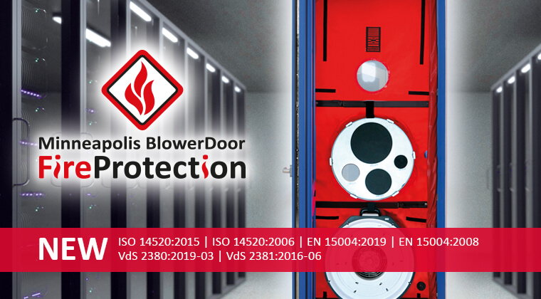

BlowerDoor GmbH
Press contact: Andrea Doll
doll@blowerdoor.de
www.blowerdoor.com

