Minneapolis BlowerDoor Measuring Technology now also with WiFi Link

Planned to begin in mid-March 2014, all BlowerDoor Measuring Systems will come with a new version of the measuring technology as well as, upon request, WiFi Link for wireless data transmission.

The WiFi Link is attached to the DG-700 pressure gauge. The data recorded during the BlowerDoor measurement (fan and building pressure) are transmitted to the notebook wirelessly and fed into the new software version of TECTITE Express 4.1. Thanks to the wireless connection, you can control the BlowerDoor measurement from your notebook independently of your installed BlowerDoor measurement system, and the measurement can easily be conducted from any location in the building. It will also be possible to control the measuring system through an iPhone app. The current building pressure and air change rate of n₅₀ are displayed on your smart phone in real time, so that this information is accessible at all times – even during leakage detection in the building, for example.

In addition to the automated BlowerDoor measurement, other new features of the TECTITE Express 4.1 measuring software include the possibility of conducting semi-automated or, if required, manual tests and including the calibration date of the pressure gauge and measuring fan in the BlowerDoor test log. 12 pressure stages can be selected for each measurement series. For unfavorable climatic conditions or specific building properties, the accuracy of the measurement can be increased further by entering up to 1,000 measuring points per pressure stage. Each measurement series also includes the interior and exterior temperature as well as the corresponding air pressure. The modular set-up allows you to add a DG-700 pressure gauge or the WiFi function to the existing BlowerDoor measuring system at any time.

For further information consult: www.blowerdoor.com

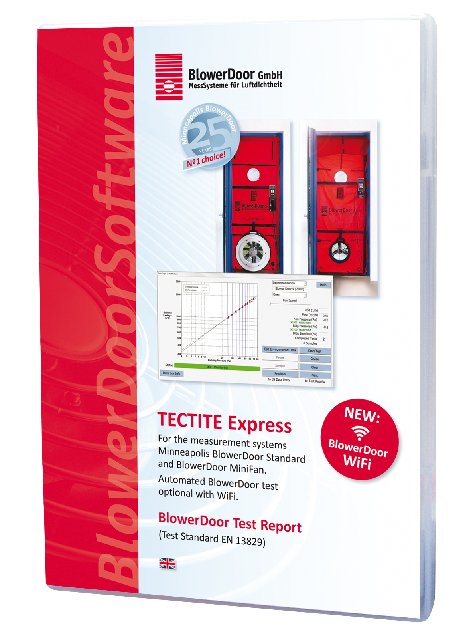
Characters (including spaces): 1,901

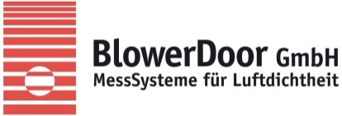

BlowerDoor GmbH
MessSysteme für Luftdichtheit
Zum Energie- und Umweltzentrum 1
31832 Springe-Eldagsen
info@blowerdoor.com
www.blowerdoor.com

Press liason:
Ms. Andrea Doll
Phone: 05044 975-45
E-Mail: info@blowerdoor.de

